# Thinking like a chemist

Heat is preserved, it is only transferred. This is how the sun provides us with Energy.

The sum of the elements (neutrons, protons, electrons (negligible)) is lesser than the sum of their weights because energy is released when they join into the nucleus of an atom (E=mc2)

E=mc2 shows that there is a lot of energy stored in a small amount of mass (since the mass is multiplied by the speed of light and squared)

Energy is the ability to do work, such as moving objects or transferring heat.

Mass is measured in kg

Weight in Newtons

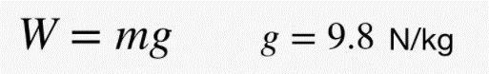

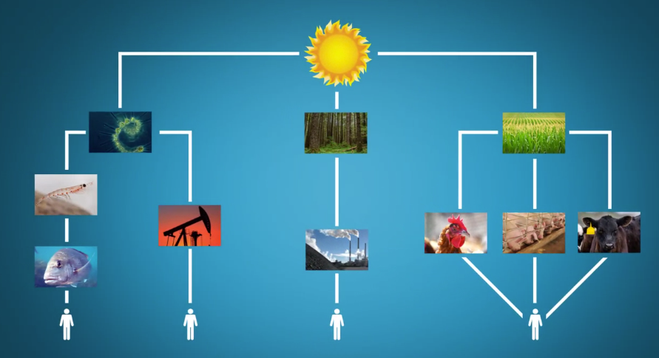

krill

phytoplankton

# Understanding how others think (mind perception)

Whether people have a consciousness/mind is usually perceived based along two dimensions or metrics:

* Agency/Thinkers/Actions
* Experience/Feelers (whether one can feel based on external inputs)

While babies and animals have feelings/experience they don’t have as much agency as adults. Companies have agency but no feelings.

### People make moral judgements based on these mind perceptions

Typically, the more you see someone as a thinker, the lesser you see them as a feeler.

When it comes to punishment or taking responsibility it’s usually based those attributes. One that does not feel is not being punished nor made responsible. One that feels but doesn’t have the capacity for agency is usually not made responsible.

This also applies to adults. E.g. hero vs. victim strategy for people that are guilty of a crime. The victim strategy emphasizes on showing that the person has feelings and not so much on agency, hence the punishment will be lesser than if the person is showcased as a hero with the emphasis on agency.

When going for a job interview on the other hand it’s better to be perceived as a thinker by wearing a business suit rather than showing too much skin.